BE[CSE] – 7ⁿᵈ Sem Minor Project (Dec 2025)
ShadowTrace

1. Title
ShadowTrace – Real-Time, Extensible macOS Observability & Control (Rust & C Backend)
ShadowTrace is a macOS application that gives you real-time visibility and control over every corner of your system—CPU, memory, disk, network, and file activity—powered by lean Rust and C code for minimal overhead. Through five progressive phases—live monitoring, automated plugin reactions, detailed system-call tracing, instant configuration changes, and a full developer toolkit with log exports and an easy-install Mac package—ShadowTrace makes it effortless to watch, respond to, and extend your Mac’s behavior.

2. Brief Introduction
ShadowTrace is a macOS app that watches everything your computer does, from which programs are running to which files are changing, all with extremely fast, low-overhead code in Rust and C—no Python involved. It rolls out in five steps:
- Basic Monitoring: Continuously track CPU, memory, disk, network, and file activity in real time.
- Automated Responses: Let small “plugins” react to important events—like sending you an alert when a program uses too much memory.
- Deep Tracing: Record detailed system calls and file changes to help you diagnose exactly what happened and when.
- Custom Configuration: Use a simple settings file to turn any part of the monitor or plugin system on or off without rebuilding the app.
- Developer Toolkit & Exports: Provide a ready-made kit for other programmers to write their own plugins, plus easy export of logs and dashboards, and a fully packaged, signed Mac installer.

3. Aim
- Phase I (“The Eye”)
  - Write Rust daemons for CPU, memory, disk, and network metrics using sysinfo and IOKit bindings in C.
  - Implement C–based FSEvents watcher for file-I/O, exposing a zero-copy ring buffer.
  - Serve JSON-RPC over Unix sockets with a Rust + tokio server.
- Phase II (“The Hand”)
  - Embed a Rust plugin engine loading .dylib modules, exposing a C ABI for plugins in Swift or C.
  - UI to register triggers; plugins can be written in Rust or plain C.
- Phase III (“The Engine”)
  - Enhance file tracing throughput with a C ring-buffer queue integrated via FFI into Rust collector.
  - Implement remediation hooks entirely in Rust (e.g., std::process::Command to run shell/AppleScript).
- Phase IV (“The Mesh”)
  - Package all Rust and C modules into a single Xcode project.
  - Parse shadowtrace.yaml config in Rust using serde_yaml; no Python.
  - Dynamically enable/disable collectors and plugins at runtime.
- Phase V (“The Mind”)
  - Provide a Rust-based plugin SDK (Cargo templates) and C header files.
  - Generate local API docs with rustdoc + Doxygen for C.
  - Add CSV/PNG export implemented in Rust (csv crate) and C (libpng).
  - Produce a signed, notarized .dmg bundling SwiftUI front-end and Rust/C backend.

4. Tools & Technologies
- Rust Crates: sysinfo, tokio, serde/serde_yaml, jsonrpc-core, csv
- C Libraries & APIs: IOKit for CPU/memory, DiskArbitration, FSEvents API, libpng, POSIX APIs
- FFI & Interop: Rust’s cc crate for building C modules; #[repr(C)] for structs; dlopen/dlsym for plugin loading
- Frontend: Swift 5 + SwiftUI; JSON-RPC client over Unix sockets
- Configuration: shadowtrace.yaml parsed in Rust (serde_yaml); JSON Schema validation via Rust types
- Packaging & Signing: Xcode project integrating Rust/C builds via cargo build --release + custom Run Script; codesign, notarytool, create-dmg

5. Expected Outcome
- Phase I: Sub-10 ms sampling daemons for CPU, RAM, disk, network; FSEvents watcher pushing events into Rust ring buffer; overall backend < 2 % CPU.
- Phase II: Plugin panel in UI driving Rust .dylib or C plugins; trigger actions and log to ~/Library/Logs/ShadowTrace.
- Phase III: High-throughput file event queue (> 10 k events/s) without drop; remediation commands executed from Rust handlers.
- Phase IV: Single macOS .app loading config at startup; hot-toggle collectors/plugins per YAML without restart.
- Phase V:
  - SDK: Cargo template project and C header + sample.
  - Docs: rustdoc HTML + Doxygen output in Documentation/.
  - Exports: CSV via Rust csv crate; PNG snapshots via libpng calls in C.
  - Installer: Signed, notarized .dmg with silent-install support.

- Proposed Logo (Initially)

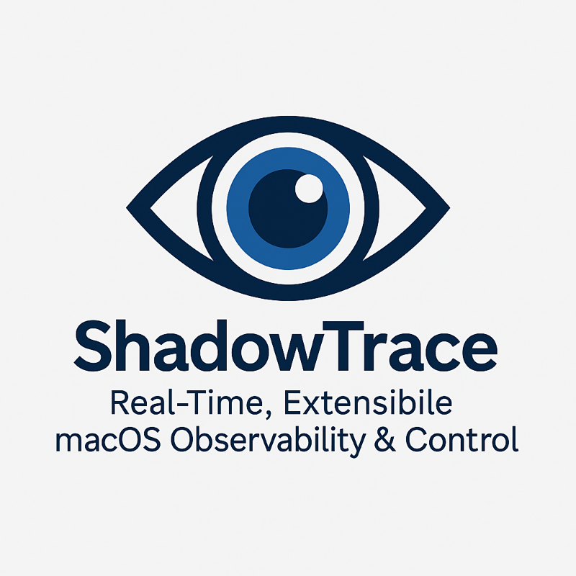

7. Gantt Chart
Weeks | Dates | Activity (Rust & C Backend)
1–2 | 04 Aug–17 Aug | Phase I: Build Rust daemons (sysinfo, IOKit bindings), C FSEvents watcher, RustNIO JSON-RPC server
3–4 | 18 Aug–31 Aug | Phase II: Rust plugin engine; UI for loading .dylib/C modules; logging framework
5–6 | 01 Sep–14 Sep | Phase III: Integrate C ring buffer queue; implement remediation handlers in Rust
7–9 | 15 Sep–05 Oct | Phase IV: Merge Rust/C builds into Xcode; serde_yaml config loader; dynamic module toggling
10–12 | 06 Oct–26 Oct | Phase V: Create Rust & C SDK templates; generate docs (rustdoc + Doxygen); implement CSV/PNG export; package
13–14 | 27 Oct–09 Nov | Testing & Optimization: 72 h stability; backend CPU < 2 %; plugin stress tests
15 | After Minor 2 | Mid-Term Evaluation (25 %)
16–18 | 10 Nov–30 Nov | Final Bug-Fix & Demo Prep: polish UI, finalize slides, rehearse
19 | After Minor 2 | Final External Evaluation (25 %)

8. Team Members & Roles
1. Tikshananshu
Role – System Architect and Designer
Responsibilities:
- Design the observability core (syscall tracing, PID tracking, resource telemetry)
- Interface with fs_usage, proc_pidinfo, sysctl, auditd, and vm_stat
- Handle core logging, error recovery, and performance tuning
- Design the internal data schema (syscall logs, file events, plugin triggers)
Skillset Required:
- C / C++ / Rust
- Experience with macOS tracing tools (DTrace, fs_usage, libproc)
- Familiarity with Mach APIs, task_info, sysctl trees
- Strong focus on performance, resilience, and debugging

2. Nihal Pandey
Role – Backend Engineer and Designer
Responsibilities:
- Build the plugin engine (trigger–response architecture)
- Design plugin API schema and dynamic loader
- Implement sandboxing, plugin crash isolation, resource-limited execution
- Connect plugins to core triggers (syscall, memory, file, network)
Skillset Required:
- Rust or C++
- Python (for rapid prototyping of the plugin API)
- Multiprocessing, IPC, subprocess control
- Familiarity with sandbox-exec, UNIX pipes, plugin packaging

3. Simarpreet Singh
Role – UI/UX Designer
Responsibilities:
- Build the native SwiftUI dashboard interface
- Integrate Combine and observable data flows from the backend
- Implement charts (using Swift Charts/CoreAnimation), memory & network overlays, Secure Mode display
- Handle export controls, search, and PID-tree rendering
Skillset Required:
- Swift, SwiftUI, Combine
- Data-driven animation with CoreAnimation or Swift Charts
- UI optimization for 60 FPS under load
- File I/O and log-viewing integration for plugin/event exports

B. Collective Responsibilities
All team members will:
- Version Control: Use Git (GitHub/GitLab), commit daily, branch per subsystem
- Testing: Join weekly integration tests (trace recovery, plugin injection, export correctness)
- Documentation: Maintain inline docs, comment all plugin logic, draft final report sections
- Internal Reviews: Rotate Friday code reviews of each other’s modules
- Bug Triage: Keep a shared bug/issue tracker for crashes or permission failures
- Stress Testing: Alternate building ≥ 2 hr monitoring sessions to validate stability

C. Collaboration Protocol
- IDEs:
  - Xcode (UI, Swift)
  - VSCode or Vim (C/Rust backend, plugin core)
- Communication:
  - Shared Notion/GitHub board for issues
  - Weekly report & demo reviews (Saturdays)
  - Plugin registry with signature, trigger, action metadata
- Development Model:
  - Subsystem branches (tracer-core, dashboard-ui, plugin-engine)
  - Merge to main only after passing CI/tests
- Deployment Order:
  - CLI-based syscall tracer + resource monitor
  - Plugin engine with 3 base plugins
  - SwiftUI dashboard with live feeds
  - Sensor/network/clipboard layer
  - Secure Mode, export engine, documentation

